**File system hierarchy overview**

**--------------------------------------------**

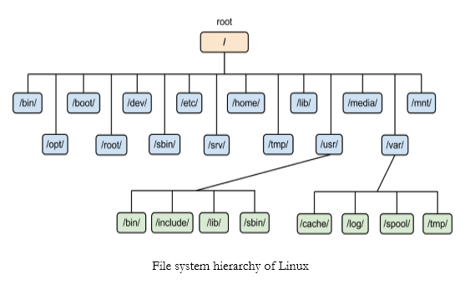

**/** : The file system root directory, from where hole tree starts .

**/root** : It is the Admin or root user home directory

**/Home** : All normal user home directory .

**/boot** : Contains static files for the boot loader. This directory holds only the files which are needed during the boot process.

**/bin** : This directory contains executable programs, which helps to execute commands by all users .

**/sbin** : This directory contains executable programs, which helps to execute command only by super user or Admin user by default .

**/dev** : It contains Special or device files, which refer to physical devices such as Hard Drive .

**/etc** : Contains configuration files which are local to the machine .

**/lib** : This directory should hold those shared libraries that are necessary to boot the system .

**/media** : This directory contains mount points for removable media such as CD and DVD disks or USB sticks.

**/mnt** : This directory is a mount point for a temporarily mounted file system .

**/opt** : This directory should contain add-on packages that contain static files .

**/proc** : It provides information about running processes and the kernel .

**/run**: This directory contains information which describes the system since it was booted.

**/srv** : This directory contains site-specific data that is served by this system.

**/sys** : This is a mount point for the sysfs file system, which provides information about the kernel like /proc.

**/tmp** : This directory contains temporary files which may be deleted with no notice, such as by a regular job or at system boot up. And the life span of this containts is 10 days.

**/usr** : This directory is usually mounted from a separate partition. It should hold only shareable, read-only data.

**/var** : This directory contains files which may change in size, such as spool and log files.

**/var/tmp** : Like /tmp, this directory holds temporary files stored for an unspecified duration. The life span for these contains is 30 days.